**A Project Report On**

**Hotel Management System**

DEVELOPED BY:

IT012 – JAY BHUVA

IT013 – ZEEL BODA

IT021 – YASHVI CHAUHAN

Guided By

Internal Guide:

Prof. Pooja Makwana

Department of Information Technology

Faculty of Technology

DD University



Department of Information Technology Faculty of Technology,

Dharmsinh Desai University College Road, Nadiad-387001

March-2023

**CERTIFICATE**

This is to certify that the project entitled “Hotel Management System” is a bonafide report of the work carried out by

1. JAY BHUVA Student ID No: 21ITUOS052
2. ZEEL BODA Student ID No: 21ITUON154
3. YASHVI CHAUHAN Student ID No: 21ITUBS044

Of department of Information Technology, Semester IV, under the guidance and supervision for the subject Database Management System. They were involved in project training during the academic year 2022-2023.

Prof. Pooja Makwana

Project Guide, Department of Information Technology,

Faculty of Technology,

Dharmsinh Desai University, Nadiad.

Date:

Prof. Vipul Dabhi

Head, Department of Informaation Technology

INDEX

I.Certificate.............................................................................2

II. Commendation................................................................. 3

1. SYSTEM OVERVIEW........................................................4

a. Current system..................................................................4

b. Advantages of the Proposed system (over current)..........4

2. E-R Diagram…………………………………………….........5

3. Relational Schema……………………………………………6

4. Data DICTIONARY…………….……….…….......................7

5. DATABASE IMPLEMENTATION......................................11

5.1 Create Schema ................................................11

5.2 Insert Data values.............................................13

5.3 Queries………...................................................17

5.4Queries (Based on Joins & Sub Queries)……...17

**1.SYSTEM OVERVIEW**

One of the most important sector for the economic growth of the country is the Tourism sector, where no doubt the good facilities, good behaviour and a good management plays a major role for their attraction. Hotels, Lodges, Resorts etc. Being the important for their management during stay, should have the proper manpower and equipment to provide a better service.

“Hotel” can simply, be defined as a place where bonafide traveller can receive food, shelter, provided he/she is in a position to pay for it and is in a fit condition to be received. So, in general terms, Hotel Management System is expertise in management, professional managers, technicians, manuals, systems, etc. on the basis of management fees and share of profits as incentive payment, leading to the prosperity and profit for the hotel.

The term Hotel Management System includes the management of each and every aspect related to the hotel for attraction, smoothness of handling things, and proper management. Especially the reservation, registrations, accounts, service, payment modes, extra activities should be handled and maintained carefully and in an effective way so as to satisfy the guest as well as to check there is no leakage of profit to the hotel. The better the service, more the attraction and more the profit not only to the hotel but also indirectly to the nation.

1.3 ADVANTAGES OF THE PROPOSED SYSTEM

1 **Opportunities** – When working in a prestigious hotel, you’ll face interaction with many different people and refined individuals from all over the world including celebrities, politicians, actors, musicians & so on; thus gaining many better opportunities to level up in your career.

2 Privileged life, high salary & trips to amazing places are a few of the many perks if you can get into 5-star chains such as Ritz Carlton, Marriott, Mandarin Oriental, etc.

3 Tips and Bonuses on top of salary. Some tips can go up to 20 percent or higher when excellent service is provided.

4 Hotel Management also branches out into other areas such as-

**2. ENTITY-RELATIONSHIP MODEL**

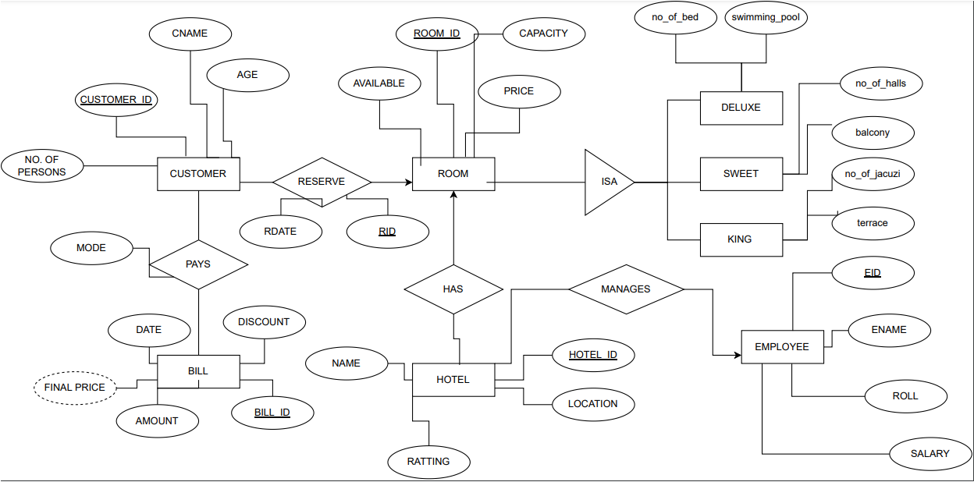

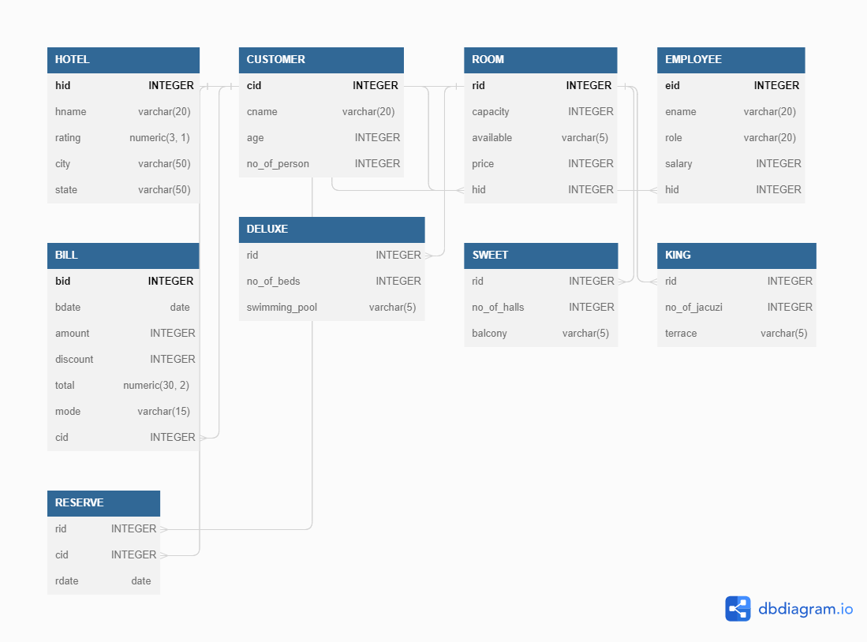

**4. Data Dictionary**

**4.1 HOTEL**

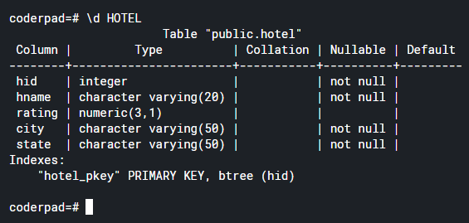

**4.2 CUSTOMER**

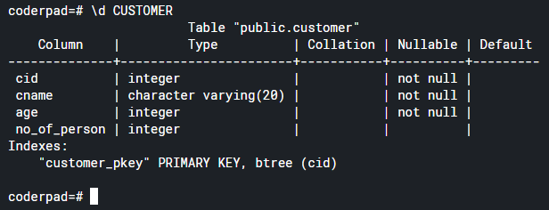

**4.3 ROOM**

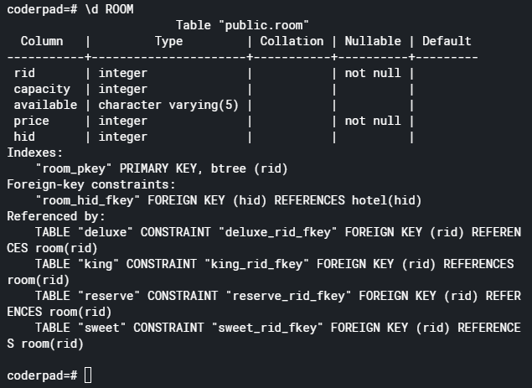

**4.4 EMPLOYEE**

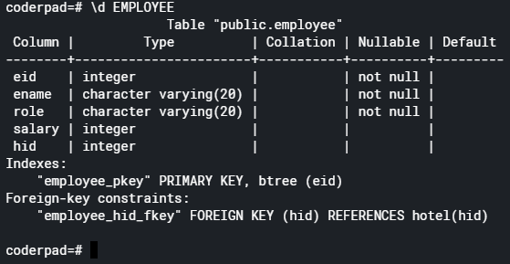

**4.5 BILL**

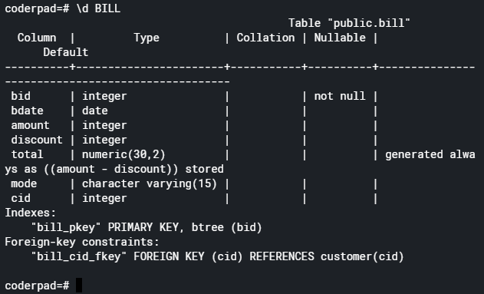

**4.6 DELUXE**

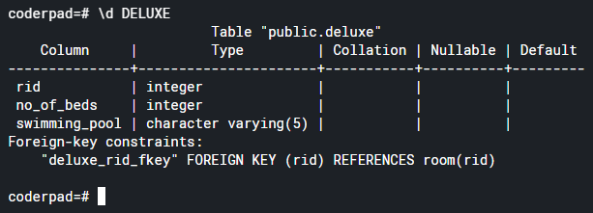

**4.7 SWEET**

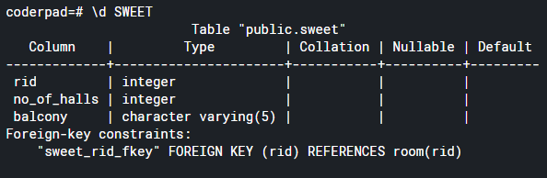

**4.8 KING**

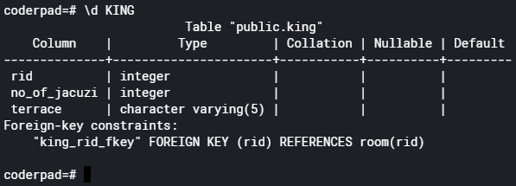

**4.9 RESERVE**

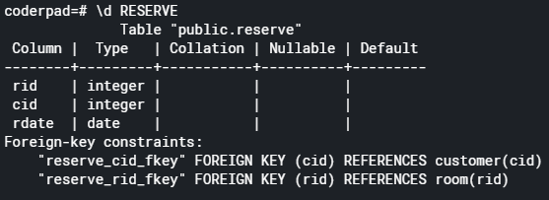

**5. DATA IMPLEMENTATION**

1. **SCHEMA**

**5.1.1 HOTEL**

CREATE TABLE HOTEL( hid INTEGER PRIMARY KEY, hname varchar(20) NOT NULL, rating numeric(3,1), city varchar(50) NOT NULL, state varchar(50) NOT NULL);

**5.1.2 CUSTOMER**

CREATE TABLE CUSTOMER ( cid INTEGER PRIMARY KEY, cname varchar(20) NOT NULL, age INTEGER NOT NULL, no_of_person INTEGER);

**5.1.3 ROOM**

CREATE TABLE ROOM ( rid INTEGER PRIMARY KEY, capacity INTEGER, available varchar(5), price INTEGER NOT NULL, hid INTEGER references HOTEL(hid));

**5.1.4 EMPLOYEE**

CREATE TABLE EMPLOYEE (eid INTEGER PRIMARY KEY, ename varchar(20) NOT NULL, role varchar(20) NOT NULL, salary INTEGER, hid INTEGER references HOTEL(hid));

**5.1.5 BILL**

CREATE TABLE BILL (bid INTEGER PRIMARY KEY, bdate date, amount INTEGER, discount INTEGER, total numeric(30,2) GENERATED ALWAYS AS (amount - discount) STORED, mode varchar(15), cid INTEGER references CUSTOMER(cid));

**5.1.6 DELUXE**

CREATE TABLE DELUXE (rid INTEGER references ROOM(rid), no_of_beds INTEGER, swimming_pool varchar(5));

**5.1.7 SWEET**

CREATE TABLE SWEET (rid INTEGER references ROOM(rid), no_of_halls INTEGER, balcony varchar(5));

**5.1.8 KING**

CREATE TABLE KING (rid INTEGER references ROOM(rid), no_of_jacuzi INTEGER, terrace varchar(5));

**5.1.9 RESERVE**

CREATE TABLE RESERVE (rid INTEGER references ROOM(rid),cid INTEGER references CUSTOMER(cid), rdate date);

1. **DATA INSERTION**

**5.2.1 HOTEL**

insert into HOTEL (hid,hname,rating,city,state) values(001,'GRAND HAYYAT GATEWAY',9.6,'MUMBAI','MAHARASTRA'),

(002,'HOTEL GRAND JYOTI',9.4,'SURAT','GUJARAT'),(003,'HOTEL GIRNAR',9.5,'JAMNAGAR','GUJARAT'),(004,'KHODIYAR DHABA',9.1,'DELHI','DELHI'),

(005,'HOTEL SKY VALLEY',8.9,'KOCHI','KERALA'),(006,'HOTEL TULSI',8.7,'NADIAD','GUJARAT'),(007,'THE GRAND BHAGVATI',9.0,'JAIPUR','RAJASTHAN'),

(008,'HOLIDAY INN',9.4,'PATAYA','THAILAND'),(009,'THE GRAND MURLIDHAR',8.8,'KUTCH','KUTCH'),(010,'HOTEL DIVYA PALACE',8.1,'KOLKATA','WEST BENGAL');

**5.2.2 CUSTOMER**

insert into CUSTOMER(cid,cname,age,no_of_person) values(001,'JAY BHUVA',19,2),(002,'ZEEL BODA',19,2),(003,'YASHVI CHAUHAN',19,3),

(004,'VRAJ CLERK',22,4),(005,'KEVIN SANGANI',20,1),(006,'MONIL GHORI',19,3),(007,'KRISH PATEL',18,1),(008,'JENIL SHAH',17,1),(009,'HARDIK PANDYA',25,3),

(010,'KRITI SANON',26,2),(011,'TIGER SHROFF',29,1),(012,'DIVYA PATEL',22,1),(013,'JILL DOSHI',18,1),(014,'NITYA PANJVANI',20,3),(015,'ARYAN PARIKH',19,1);

**5.2.3 ROOM**

insert into ROOM(rid,capacity,available,price,hid) values(001,5,'YES',5000,002),(002,2,'YES',3000,004),(003,3,'NO',4000,003),(004,2,'NO',3200,006),

(005,1,'NO',1300,007),(006,2,'YES',3150,008),(007,4,'YES',5600,005),(008,5,'NO',7000,006),(009,1,'NO',1200,001),(010,2,'NO',2300,009),(011,4,'YES',6500,001),

(012,1,'YES',1250,007),(013,3,'NO',3450,004),(014,5,'YES',7000,010),(015,4,'NO',6000,005);

**5.2.4 EMPLOYEE**

insert into EMPLOYEE(eid,ename,role,hid,salary) values(001,'RAKESH KUMAR','MANAGER',002,12000),(002,'ABHISEKH PATEL','WAITER',003,3500),

(003,'ANIL KUMAR','WORKER',005,2000),(004,'JASH SHAH','ASSISTANT',006,5000),(005,'RAJ JANI','COOK',007,4000),(006,'PREETI RAJ','HEAD CLERK',004,6000),

(007,'SAIYAD ANSARI','STAFF',001,3500),(008,'YASHRAJ GAIKWAD','RECEPTIONIST',009,7000),(009,'UMESH KUMAVAT','CLEANER',010,3750),(010,'RAJ PRASAD','COOK',007,4500);

**5.2.5 BILL**

insert into BILL(bid,bdate,amount,discount,mode,cid) values (001,'18-NOV-2020',7000,70,'online',005),(002,'20-SEP-2022',1500,150,'online',002),(003,'22-AUG-2021',15000,3000,'offline',001),(004,'15-FEB-2023',5600,300,'offline',009),(005,'06-JAN-2020',2500,125,'online',006),(006,'01-JUNE-2021',8900,2222,'offline',003),(007,'13-MAY-2023'

,6000,2320,'offline',007),(008,'07-SEP-2020'

,7000,70,'online',008),(009,'29-OCT-2021',6100,590,'offline',010),(010,'19-SEP-2023',8900,2320,'online',004);

**5.2.6 DELUXE**

insert into DELUXE(rid,no_of_beds,swimming_pool) values(001,3,'YES'),(002,1,'YES'),(003,2,'NO'),(011,4,'NO'),(012,2,'YES');

**5.2.7 SWEET**

insert into SWEET(rid,no_of_halls,balcony) values(004,2,'NO'),(005,1,'NO'),(006,1,'YES'),(013,2,'NO'),(014,3,'YES');

**5.2.8 KING**

insert into KING(rid,no_of_jacuzi,terrace) values(007,1,'YES'),(008,1,'NO'),(009,2,'YES'),(010,2,'NO'),(015,2,'YES');

**5.2.9 RESERVE**

insert into RESERVE(rid,cid,rdate) values(001,007,'21-JUNE-2020'),(003,006,'12-MAR-2021'),(004,009,'07-DEC-2022'),(006,003,'14-JAN-2020'),

(009,005,'23-JUL-2021'),(010,004,'17-OCT-2020'),(005,012,'11-AUG-2022'),(007,011,'19-JAN-2020'),(002,010,'31-OCT-2021'),(008,0014,'27-FEB-2022');

**INSERTION OUTPUT:**

**5.3.1 HOTEL**

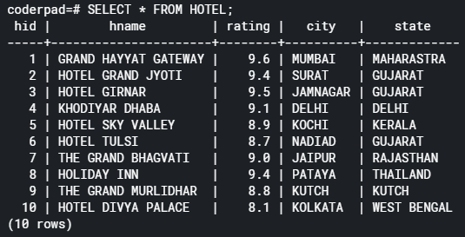

**5.3.2 CUSTOMER**

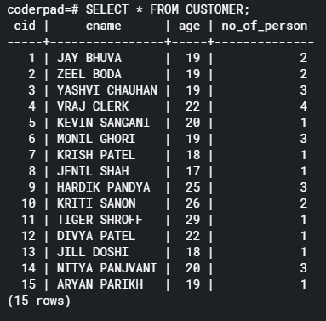

**5.3.3 ROOM**

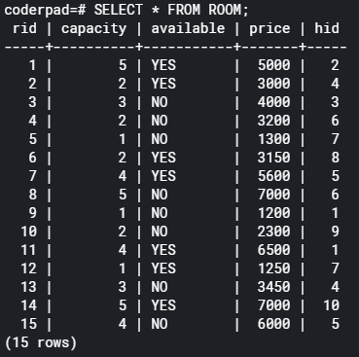

**5.3.4 EMPLOYEE**

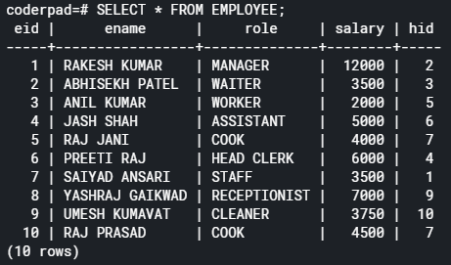

**5.3.5 BILL**

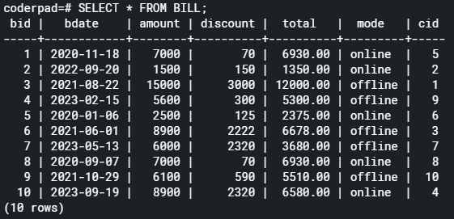

**5.3.6 DELUXE**

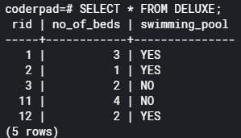

**5.3.7 SWEET**

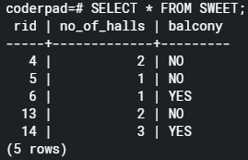

**5.3.8 KING**

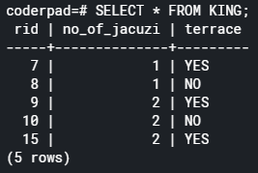

**5.3.9 RESERVE**

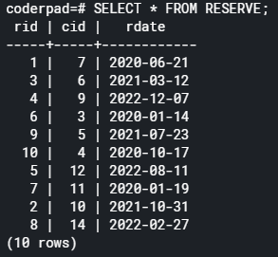

**5.4 QUERIES USING BASIC DBMS CONSTRUCTS**

**JOIN & SUBQUERIES:**

**5.4.1**

Count the number of people who had paid the bill and their birthdate is 2020-11-18.

* select count(bid) from bill where (bdate='2020-11-18');

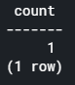

**5.4.2**

Display all hotels of maharastra.

* select hname from hotel where(state='MAHARASTRA');

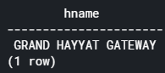

**5.4.3**

Find the maximum salary of an employee.

* select max(salary) from employee;

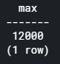

**5.4.4**

Find the name and id of the customers who have reserved the room in hotel.

* select customer.cname,reserve.rid from reserve left join customer on reserve.cid=customer.cid;

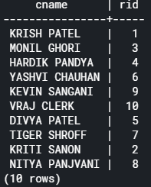

**5.4.5**

Display the customer name who had reserved a room in Nadiad and the type of the room is deluxe.

* select cname from customer inner join reserve on customer.cid=reserve.cid inner join room on reserve.rid=room.rid inner join deluxe on room.rid=deluxe.rid join hotel on room.hid=hotel.hid where (city='NADIAD');

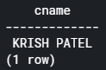

**5.4.6**

Find the name of all hotels whose rating is more than 9.0

* select hname from hotel where(rating>9.0);

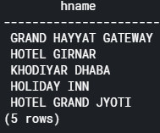

**5.4.7**

Display the name of hotel’s all employees whose id is 7

* select eid,ename from employee right join hotel on employee.hid=hotel.hid where (employee.hid=7);

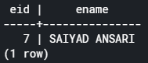

**5.4.8**

Find all customers who’s payment mode is ‘online’.

* select cname from customer where (cid in (select cid from bill where (mode='online')));

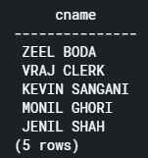

**5.4.9**

Find the id number who have reserved the deluxe room and also selected swimming_pool.

* select cid from reserve where (rid in (select rid from deluxe where (swimming_pool='YES')));

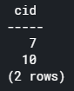

**5.4.10**

Display the name of all customers, whose name starts from letter “J”.

* select cname from customer where cname like 'J%';

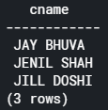

**5.4.11**

Display all details of an employee whose salary is in between 2000 to 6000.

* select * from employee where salary between 2000 and 6000;

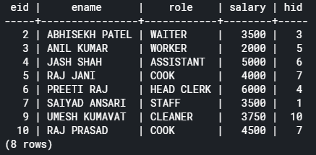

**5.4.12**

Display all details of reserved rooms with date in decreasing order.

* select * from reserve order by rdate desc;

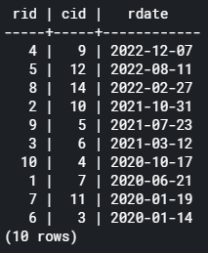

**5.4.13**

Display the number of employees in each hotel.

* select count(eid),hid from employee group by hid;

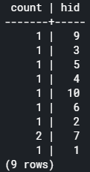

**5.4.14**

Display details of all the reservation which was done between date 5 and 15.

* select * from reserve where extract(day from rdate) between 5 and 15;

